Installation instructions: unzip to a folder and run the setup.
Created by Alex de Beer, Sylvie Roke Funding: German Science Foundation (DFG): 560398, European Research Council (ERC): 240556. Though the program is completely free, the authors would appreciate feedback on alexdebeer@gmail.com
The simulations in this program were based on the formalism presented in A. G. F. de Beer and S. Roke, J. Chem. Phys. 132, 234702 (2010) and on the following papers:
Second harmonic scattering from small particles:
J. I. Dadap et al., Phys. Rev. Lett. 83, 4045 (1999)
Sum frequency scattering formalism:
First experiments:
S. Roke et al., Phys. Rev. Lett. 91, 258302 (2003)
RGD theory:
A. G. F. de Beer and S. Roke, Phys. Rev. B 75, 245438 (2007)
Review:
S. Roke, ChemPhysChem 10, 1380 (2009)
Nonlinear Mie theory for SFG:
A. G. F. de Beer and S. Roke, Phys. Rev. B 79, 155420 (2009)
The beta values used in this simulation were based on the following publications:
A. G. F. de Beer and S. Roke, J. Chem. Phys. 132, 234702 (2010)
H. F. Wang et al., Int. Rev. Phys. Chem. 24, 191 (2005)
W. Gan et al., J. Chem. Phys. 124, 114705 (2006)
Controls
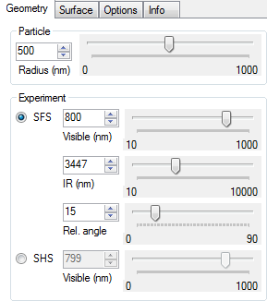
The "geometry" controls tab
The sliders in the "geometry" tab control parameters that relate to experimental and particle geometry. The top slider controls the particle radius. In the box, a radio button toggles between sum frequency scattering (SFS) and second harmonic scattering (SHS) mode. In SFS mode, the wavelength of the visible and IR beams can be set along with the relative angle of the two beams. In SHS mode, only the fundamental wavelength can be set.
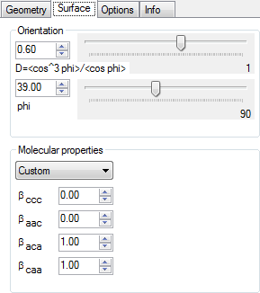
The "surface" controls tab

The sliders in the "surface" tab determine the properties of the particle interface. The average orientation of molecules at the surface can be set either with the parameter "D" or by setting the (effective) average tilt angle. In the molecular properties tab the individual values of beta can be set. Alternatively, it is possible to choose from one of the presets of the pull-down list box.
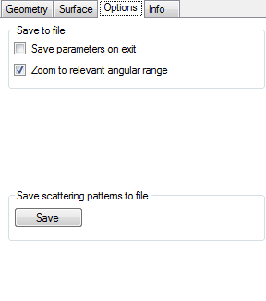
The "options" controls tab

The "options" tab allows control over some parts of the programs' behaviour: Selecting "save parameters on exit" will cause the program to remember the last used settings. "Zoom to relevant angle" will always zoom the x-scaling to that the main features of the scattering pattern are visible. Unchecking this box will make the full angular range visible. Finally, the button "save" allows saving the angular scattering pattern to disk in ASCII format.

